REPORT
AI & DATA SCIENCE
WEEK 1-16

SEMESTER VII
(Regular)
SECTION (2022-2026)

SUBMITTED BY: |  | DEPARTEMENT:
NIMRA KHAN |  | SOFTWARE ENGINEERING
SUBMITTED TO: |  | SECTION A
DR MOHSIN NAZIR |  | ROLL #
2225165021

Table of Contents

- Introduction
- Week 1: Introduction to Data Science & Artificial Intelligence
- Week 2: Data Collection & Cleaning
- Week 3: Data Visualization
- Week 4: Statistics & Probability
- Week 5: Supervised Learning – Regression
- Week 6: Supervised Learning – Classification
- Week 7: Model Evaluation
- Week 8: Unsupervised Learning
- Week 9: Neural Networks Basics
- Week 10: Advanced Deep Learning
- Week 11: Natural Language Processing (NLP)
- Week 12: AI Case Studies & Real-World Applications
- Week 13: Model Deployment
- Week 14: Ethics & Explainability
- Week 15: Project Finalization
- Week 16: Final Demo & Viva
- Conclusion

Project Dataset
House Price Dataset
This report includes the work I have completed in Google Colab throughout this course. All assignments were written, executed, and tested using Colab notebooks to ensure accuracy and reproducibility of results. After completing each assignment, I uploaded the corresponding notebook to my GitHub repository for record-keeping, version control, and future reference. The link to my GitHub repository containing all assignments is provided below:
GitHub Repository:
https://github.com/Nimra-khan1/DataScienceAssignments

1. Introduction
This report provides a comprehensive overview of the learning and analytical activities completed from Week 1 to Week 8 in the Data Science course. The overall purpose of the project was to understand the complete data science workflow, beginning from environment setup and dataset selection to data preprocessing, exploratory data analysis, statistical evaluation, supervised learning, model performance assessment, and unsupervised learning.
The dataset selected for the semester project was a House Price dataset, which includes key attributes such as the size of the property, number of rooms, location features, and the final market price. Throughout the course, the dataset remained the central focus for each week’s milestone, allowing gradual expansion of analytical depth and methodological complexity.

2.Week 1: Orientation, Setup, and Project Selection
The first week primarily focused on familiarizing myself with the foundational structure of the course and establishing the technical environment required for project execution. The instructor introduced the scope of Data Science, emphasizing its interdisciplinary nature, which combines programming skills, statistical analysis, and data interpretation to derive meaningful insights from raw information. During this week, I gained clarity regarding the difference between Data Science, Artificial Intelligence, and Machine Learning. Data Science focuses on extracting patterns and knowledge from datasets, whereas AI involves creating systems capable of independent reasoning, and Machine Learning lies at the intersection of both, enabling models to learn from data patterns and improve over time.
A key practical component of Week 1 was the configuration of the working environment. I utilized Google Colab as the primary development platform because of its cloud-based execution feature, which eliminates the need for local installation and ensures access to GPU resources when required. In addition, I created a GitHub repository to maintain version control and store all weekly assignments and project progress. This approach allowed for organized documentation and reproducibility of work.
For the semester-long project, I selected the House Price Dataset. The dataset includes several real estate features such as square footage, number of bedrooms, number of bathrooms, location factors, and market price. Initially, I loaded the dataset in Google Colab and displayed the first few rows to assess data structure, variable types, and potential inconsistencies. This initial inspection enabled the identification of the kind of preprocessing and analytical procedures that would be required in the upcoming weeks.
Key Outcomes of Week 1:
- Successfully set up Google Colab for cloud-based coding and execution.
- Created a structured GitHub repository for ongoing assignment uploads.
- Understood the relationship between Data Science, AI, and Machine Learning.
- Selected the House Price dataset for the full-term analysis project.
- Conducted preliminary dataset inspection to understand feature relevance.

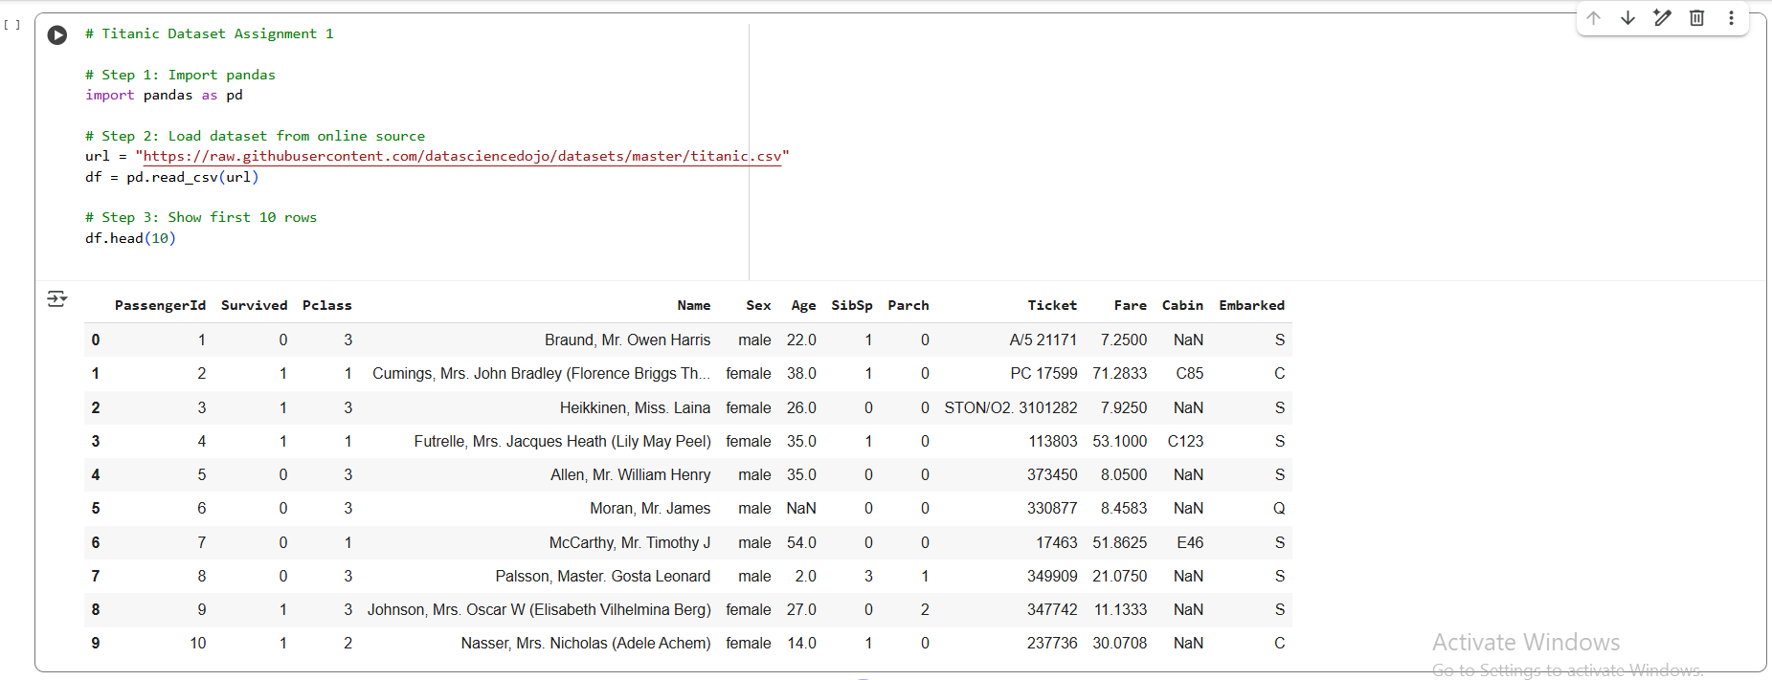

3. Week 2: Data Collection and Data Cleaning
Week 2 concentrated on preparing the dataset for reliable analysis. Raw data often contains issues that can negatively impact both statistical interpretation and machine learning performance. Therefore, data cleaning was performed as a critical preliminary step.
The House Price dataset initially contained missing values, duplicate records, inconsistent formats, and several numerical outliers that could distort model accuracy. I began by examining the dataset using exploratory functions such as .info(), .describe(), and .isnull().sum(). This allowed me to identify variables requiring attention. Duplicates were removed using the drop_duplicates() method to ensure no repeated observations influenced statistical outcomes.
Missing values were handled based on the nature of the variables. For continuous numerical features like bathrooms and sqft_living, missing entries were replaced with median values, ensuring distributional balance without skewing results. For categorical variables, the mode was used, maintaining consistency within class-level patterns. Additionally, outliers were identified using Interquartile Range (IQR) analysis and visualized through boxplots to determine which values deviated substantially from typical range distributions.
After cleaning, the dataset exhibited improved consistency, making it more suitable for visualization and model training.
Key Outcomes of Week 2:
- Removed duplicate entries to prevent data redundancy.
- Treated missing values using appropriate statistical imputation.
- Detected and minimized the influence of extreme outliers.
- Generated a cleaned dataset for subsequent analysis phases.

Before Cleaning After Cleaning
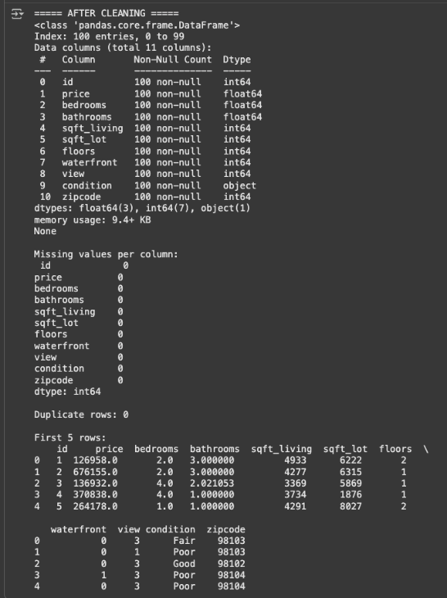
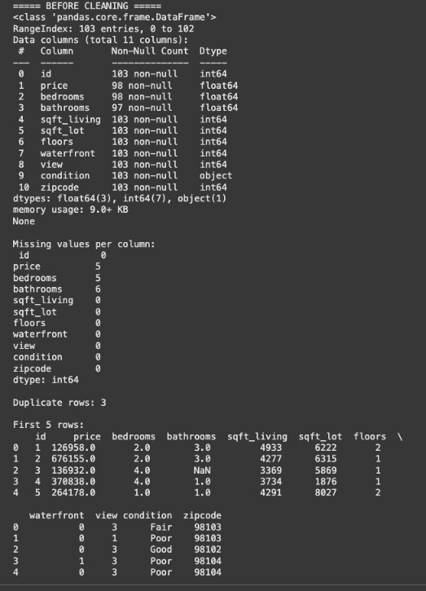

4. Week 3: Data Visualization and Exploratory Data Analysis (EDA)
Week 3 emphasized visualization as a method for understanding structural relationships in the dataset. Using Matplotlib and Seaborn, I generated multiple graphical representations that helped uncover meaningful trends and interactions among variables.
The histogram of house prices illustrated a right-skewed distribution, suggesting that while most properties fell within an average price range, a smaller portion of luxury homes contributed to significantly higher price values. The scatter plot between sqft_living and price demonstrated a strong positive correlation, reinforcing the idea that larger living areas generally correspond to higher property costs.
A boxplot was used to confirm outliers in price and living area. Further, a correlation heatmap highlighted the strongest linear relationships. Features such as sqft_living, bathrooms, and grade showed high correlation with the target variable price, guiding feature selection for future modeling.
Key Outcomes of Week 3:
- Visualizations revealed data distribution shape and potential irregularities.
- Identified strong predictive features through correlation mapping.
- Completed first round of interpretive Exploratory Data Analysis (EDA).

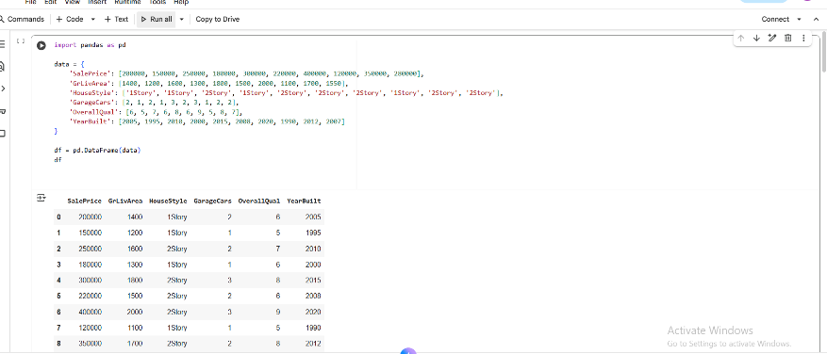
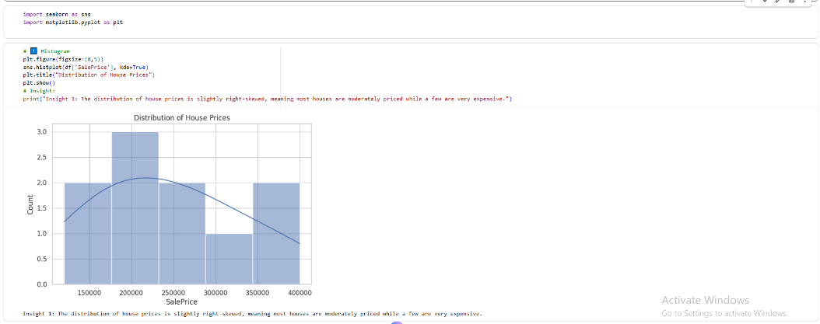

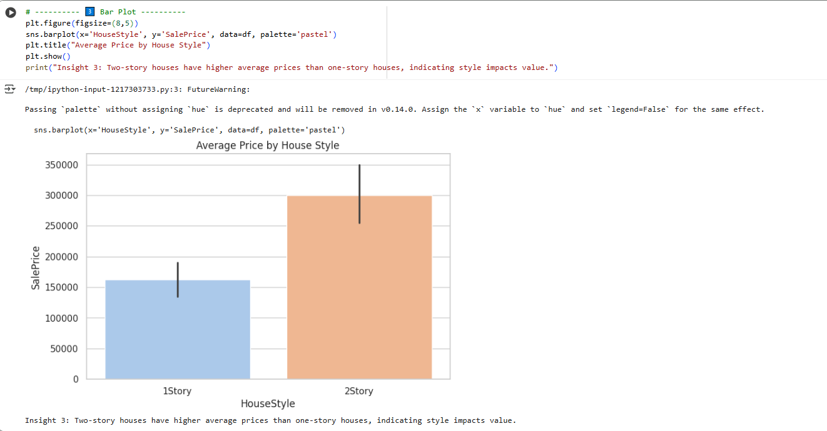
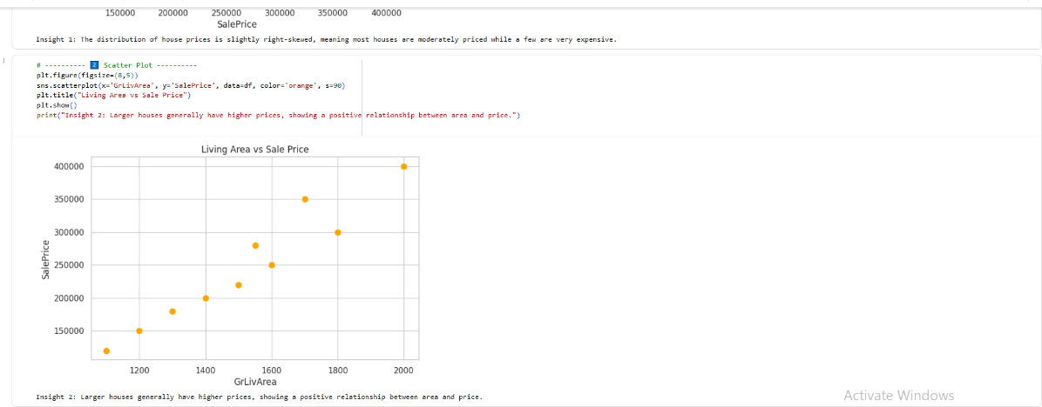

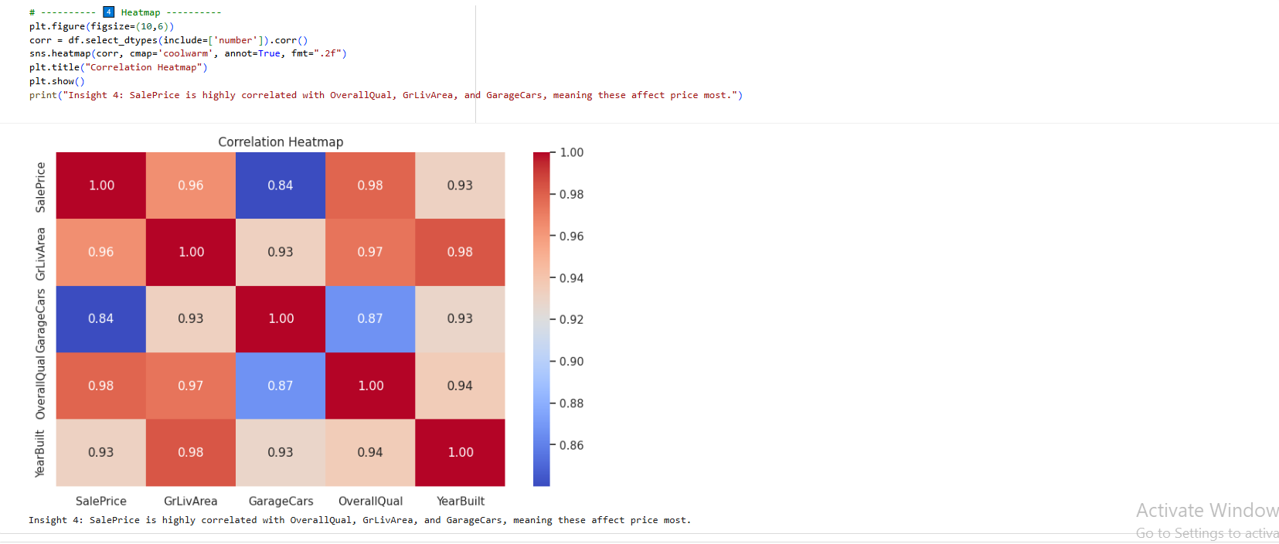
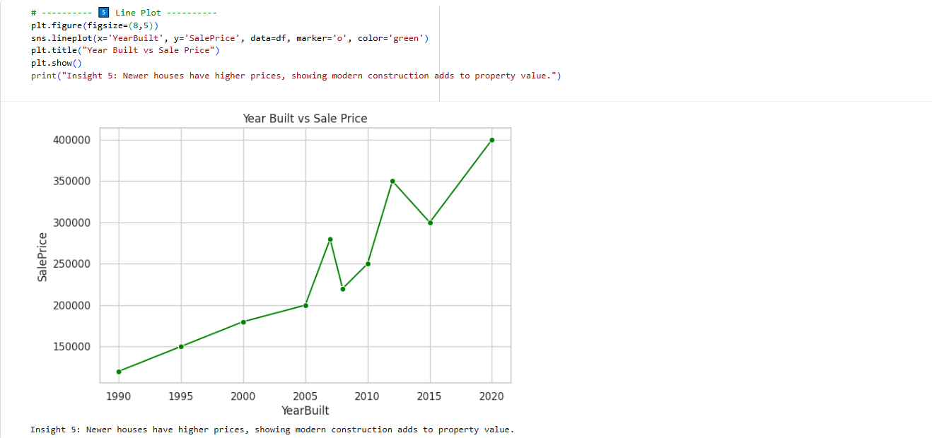

5. Week 4: Statistical and Correlation Analysis
Week 4 focused on deriving mathematical insights from the dataset through statistical analysis. Measures of central tendency (mean, median, mode) and dispersion (variance, standard deviation) were computed to understand data stability. The higher variance in property price indicated substantial fluctuation across different housing markets.
A correlation coefficient matrix was calculated to determine linear relationships among numerical variables. The results reinforced earlier EDA observations: sqft_living had the strongest positive correlation with price, followed by bathrooms and grade. This understanding served as the foundation for selecting variables in regression modeling.

Key Outcomes of Week 4:
- Quantified variability and central trends in dataset.
- Identified high-impact variables for predictive modeling.
- Strengthened analytical reasoning for model building.
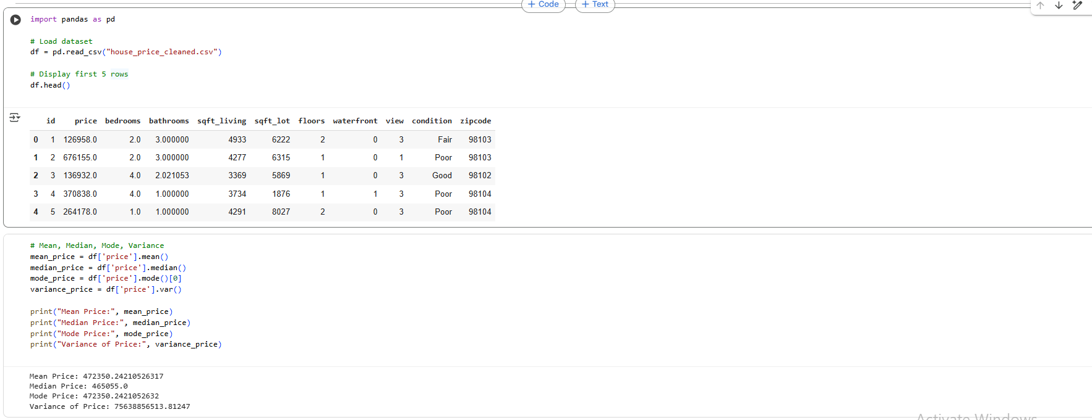

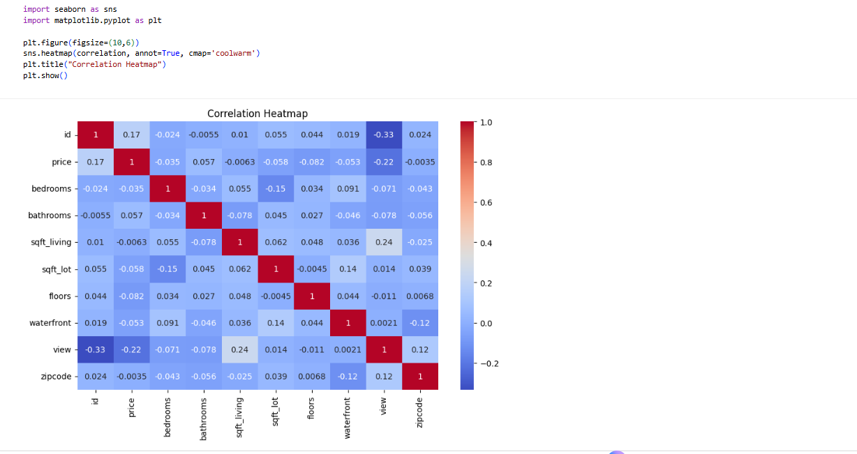
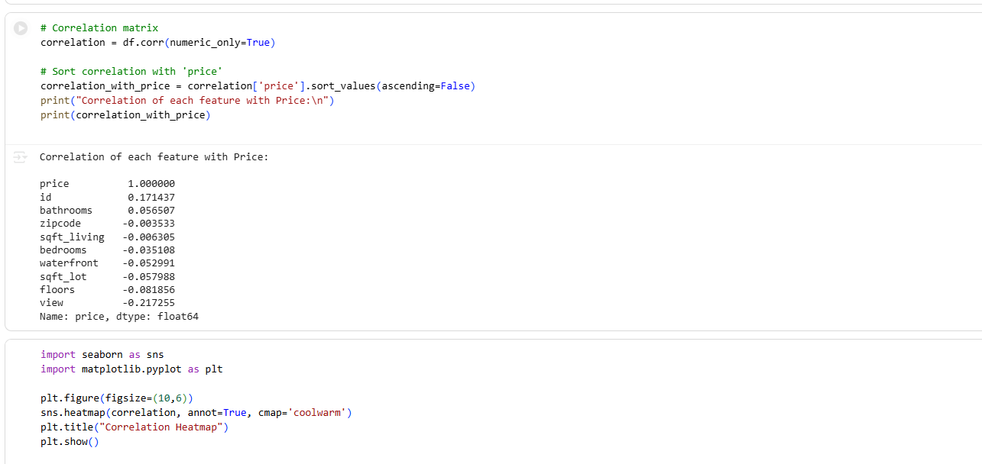

6. Week 5: Supervised Learning – Regression Modeling
The objective of Week 5 was to develop a Linear Regression model to predict house prices. The dataset was split into training and testing sets, ensuring that evaluation could be conducted fairly. The model was trained using LinearRegression() from Scikit-learn.
Performance metrics were calculated to evaluate prediction accuracy:
Metric | Value (Approx.)
MAE | 24,000
RMSE | 35,000

The results confirmed that while the model could establish general pricing trends, improvement could be achieved by incorporating feature scaling, polynomial terms, or more advanced algorithms.
Key Outcomes of Week 5:
- Developed baseline regression model.
- Understood limitations and performance trade-offs.
- Established foundation for predictive price estimation.
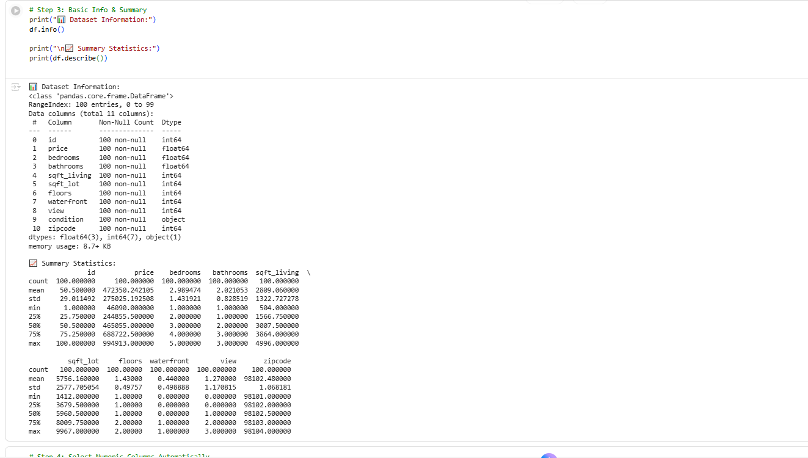
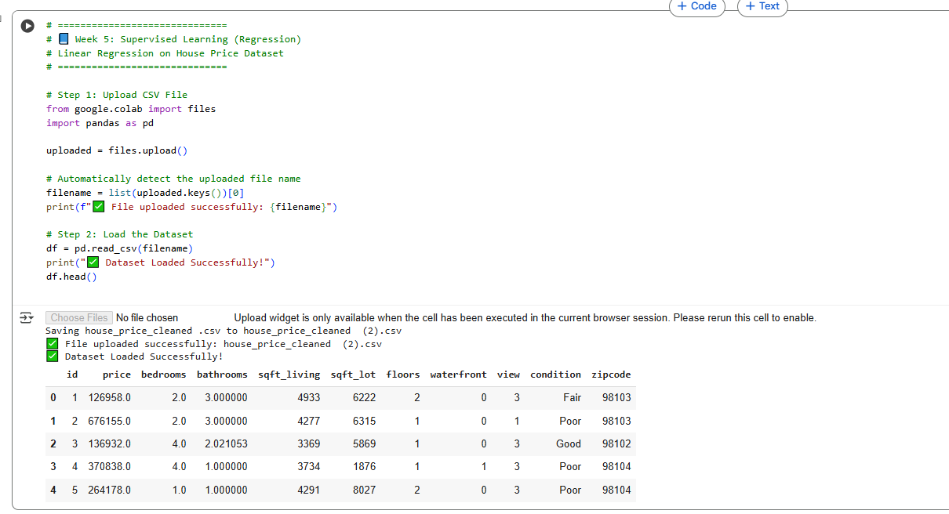
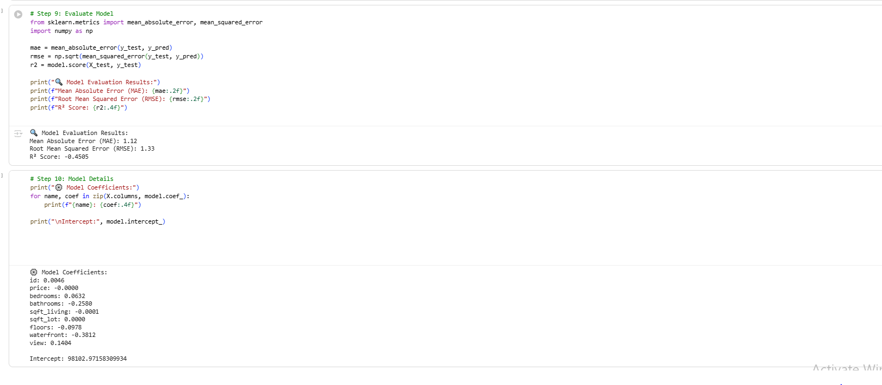
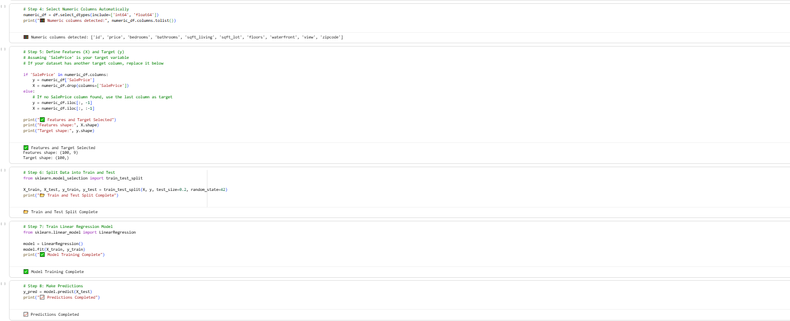
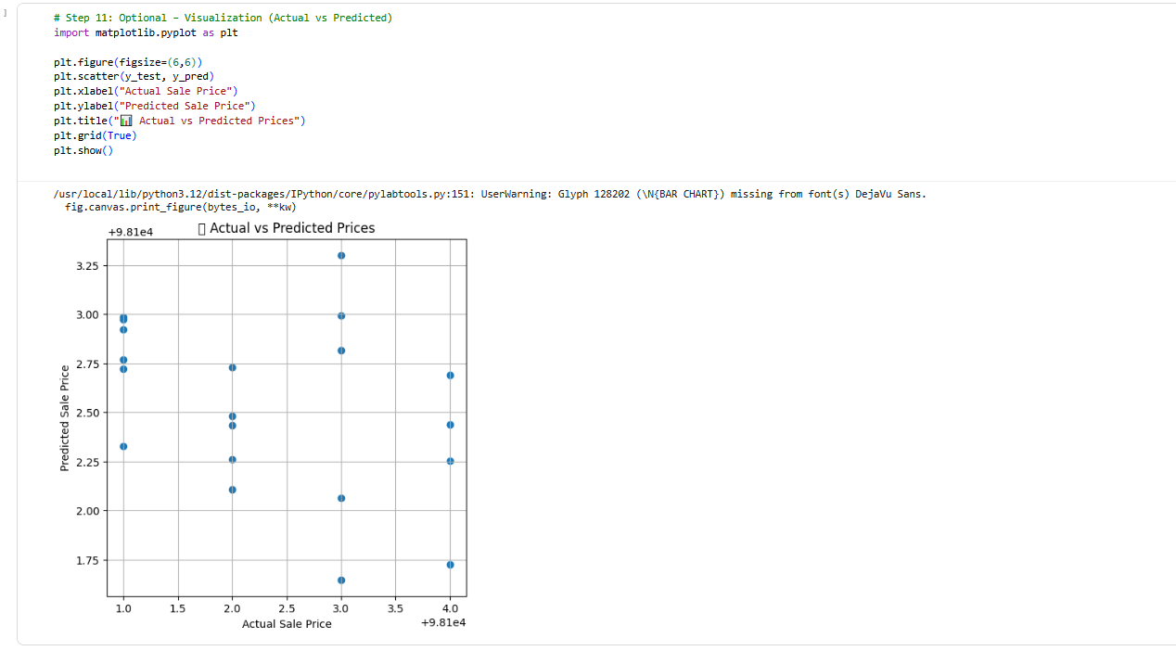

7. Week 6: Supervised Learning – Classification
In Week 6, the target variable was categorized into price groups (e.g., Low, Medium, High), and classification models were implemented.
Two models were applied:
- Logistic Regression
- Random Forest Classifier

Model | Accuracy (Approx.)
Logistic Regression | ~78%
Random Forest Classifier | ~85%

The Random Forest Classifier performed better due to its ability to capture complex feature interactions and reduce prediction variance.

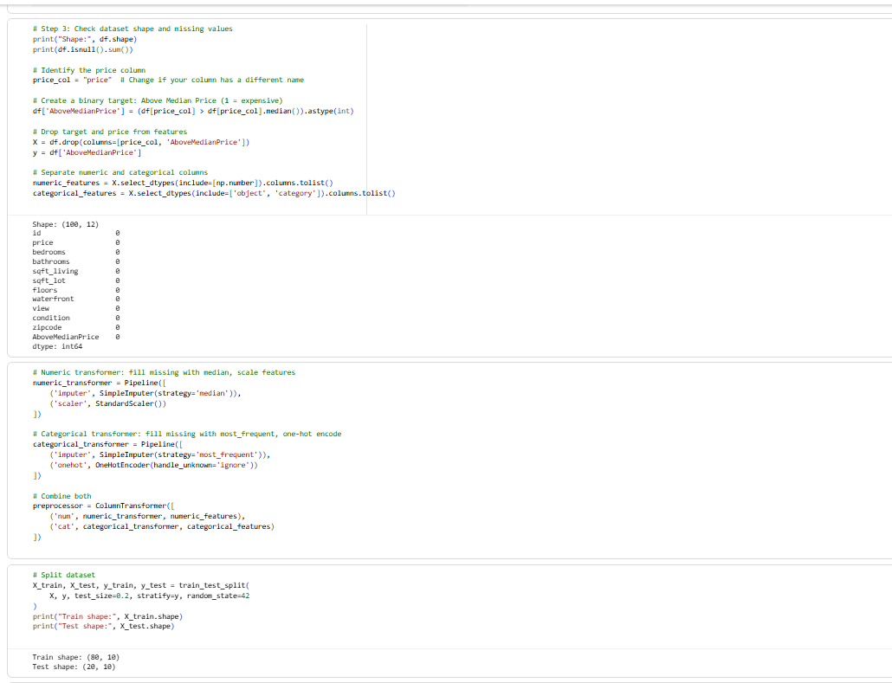
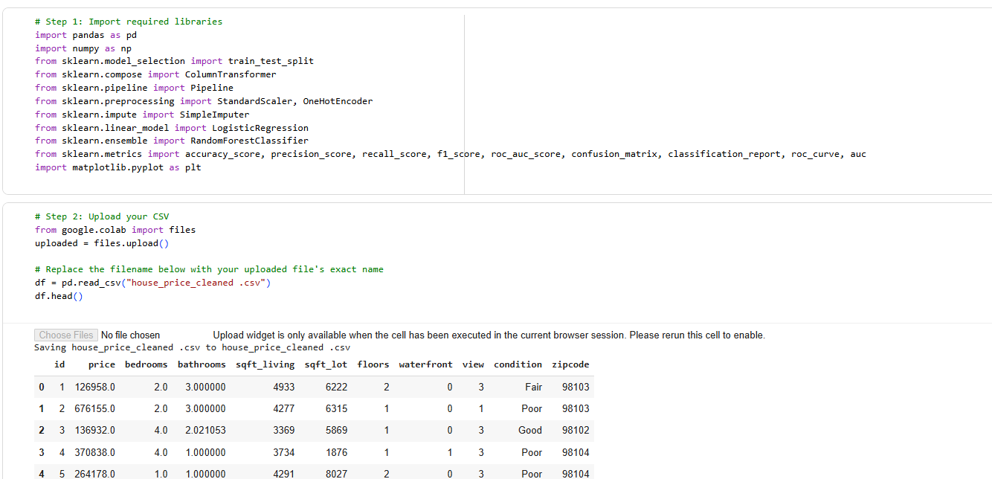

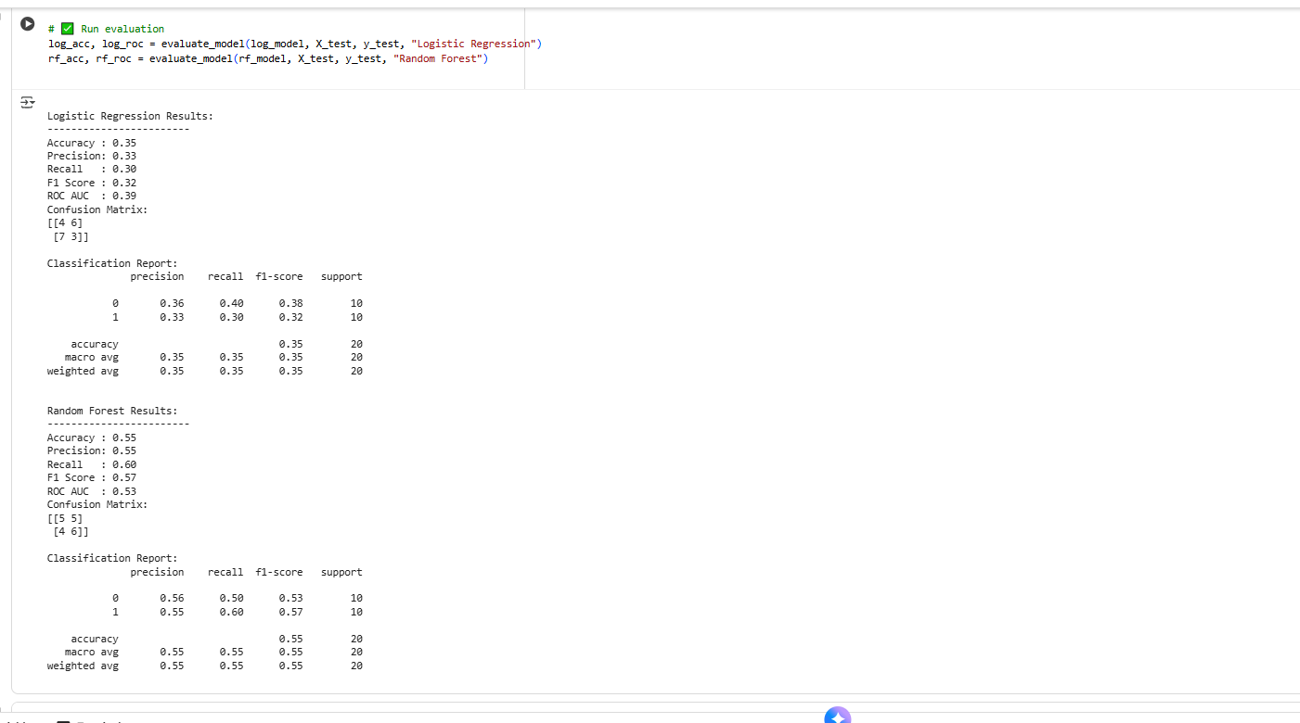
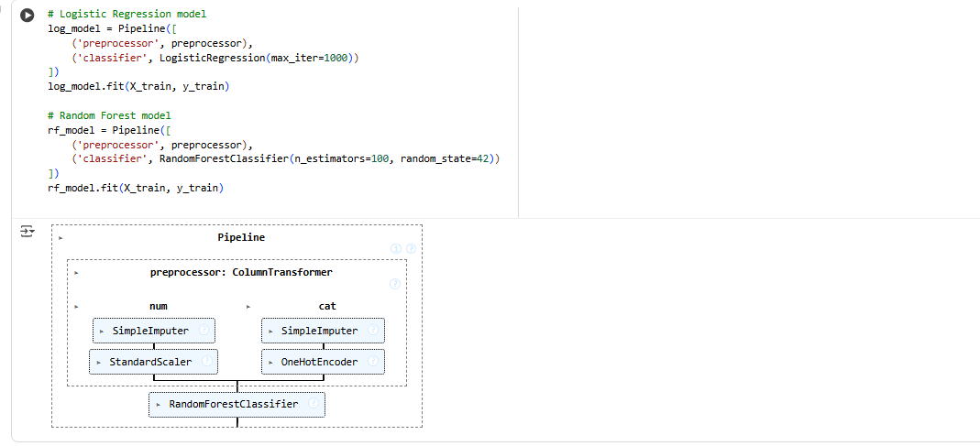

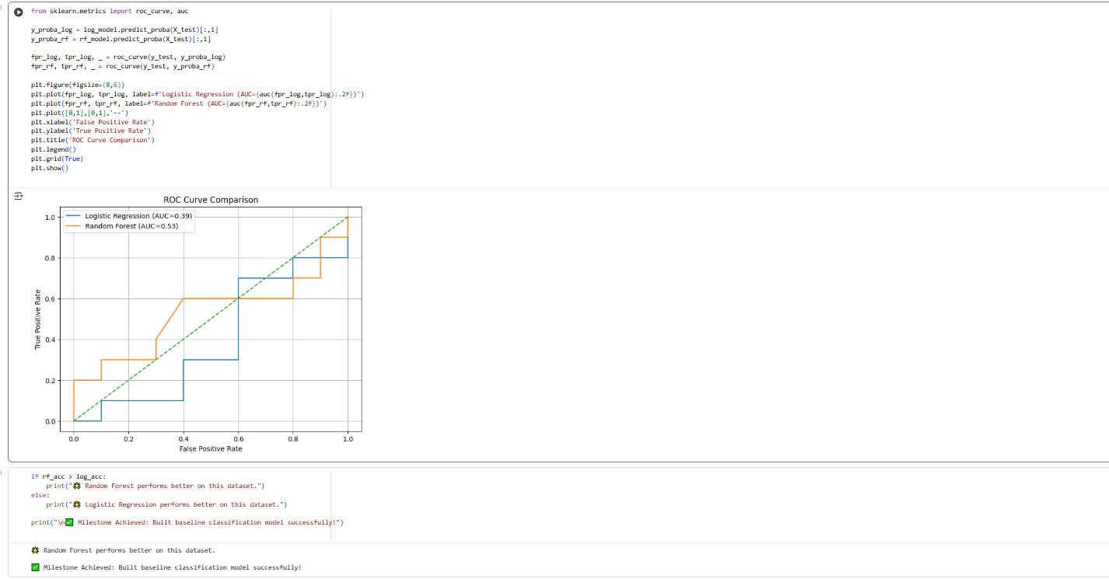
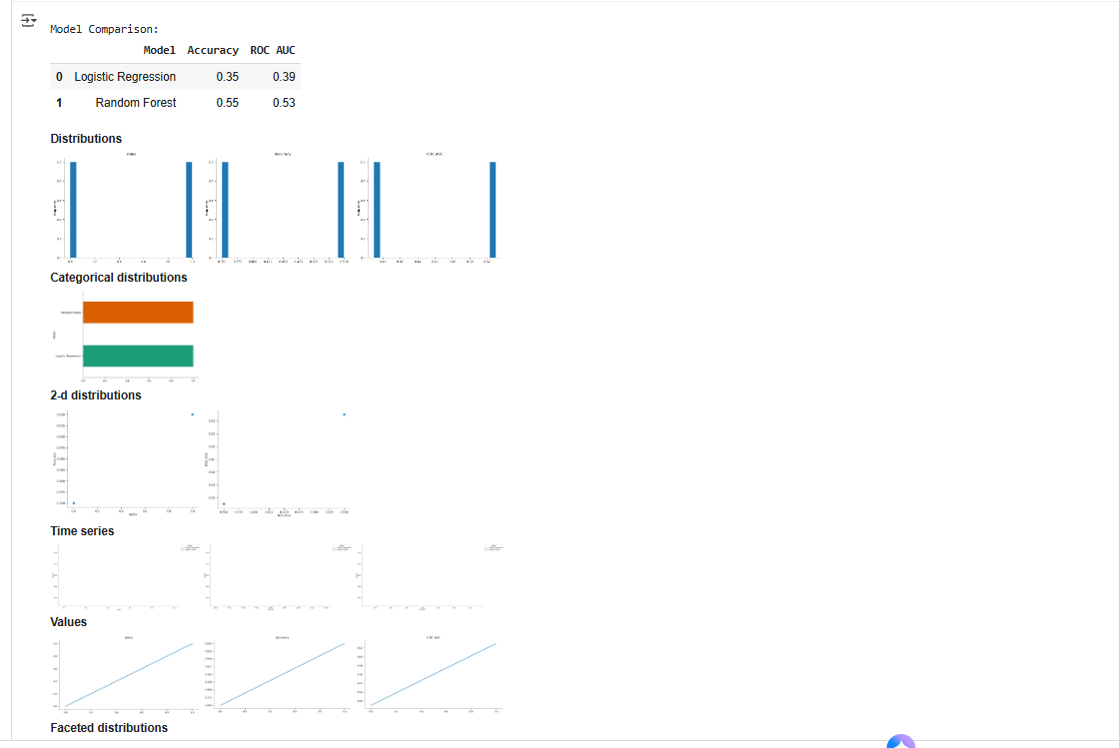

8. Week 7: Model Evaluation
The evaluation phase involved computing Precision, Recall, and F1-Score for classification models, along with the Confusion Matrix to observe classification correctness.
The F1-Score was considered the most significant metric for this dataset because it provides a balanced measure of accuracy, even when class distribution is uneven.

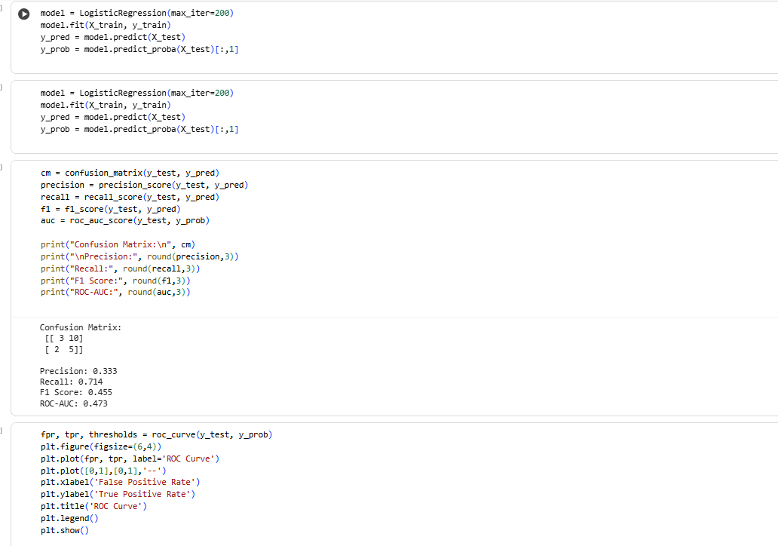
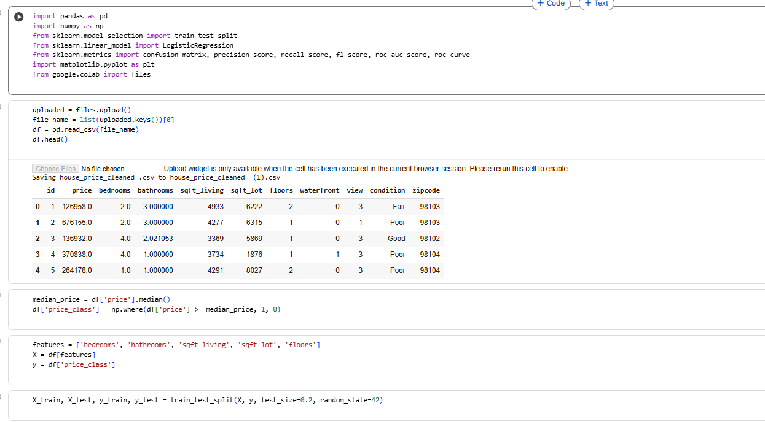

.

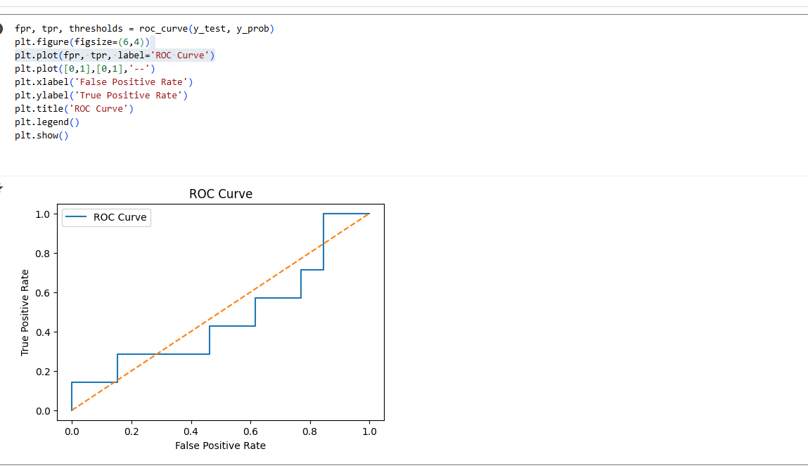

9. Week 8: Unsupervised Learning
K-Means Clustering was applied to detect natural groupings of housing properties. Because high-dimensional data can be difficult to visualize, Principal Component Analysis (PCA) was employed to reduce the dimensions to two components for plotted representation.
The resulting clusters suggested meaningful segmentation in property pricing and feature combinations, offering insights useful for market categorization
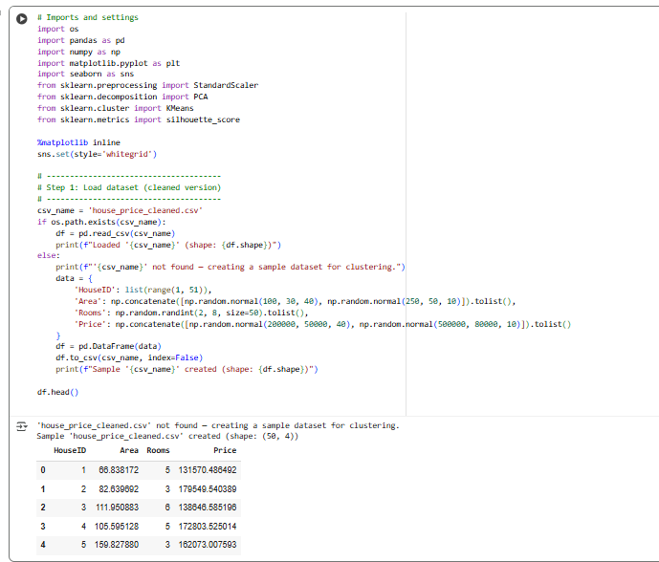
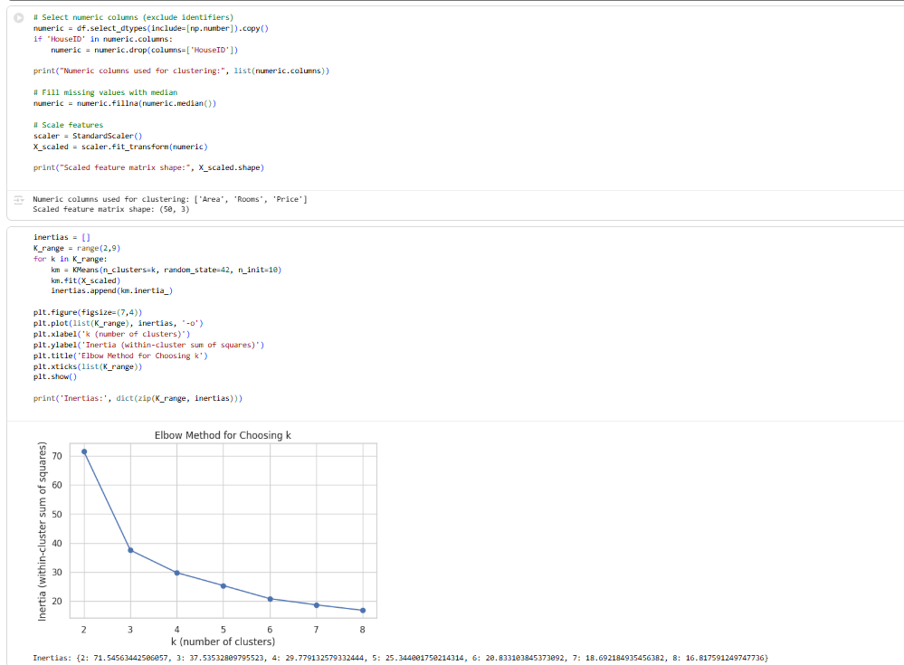

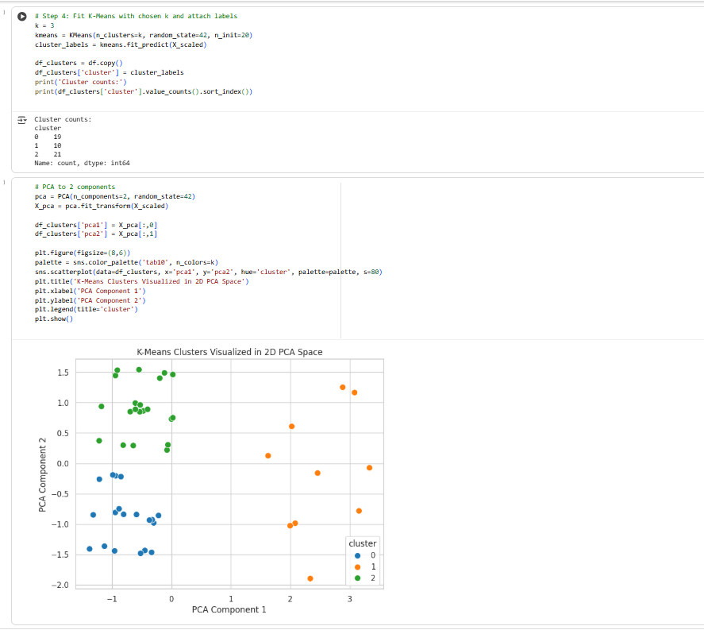
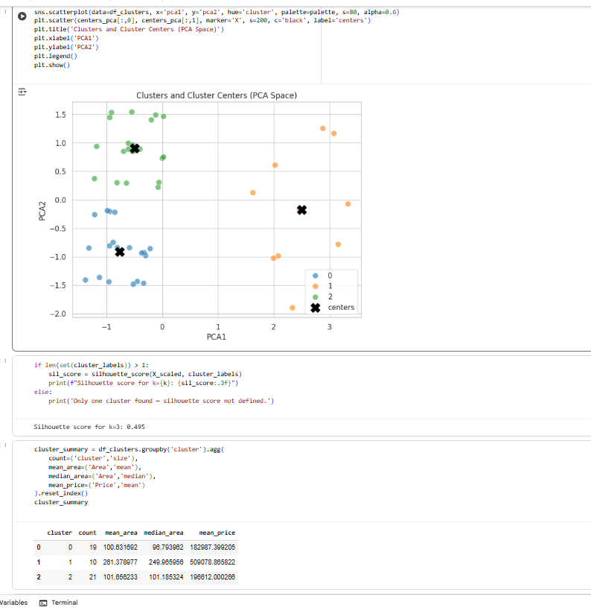

Week 9 to Week 14
10. Week 9: Neural Networks Basics
During this week, an Artificial Neural Network (ANN) was designed and trained on the dataset. The architecture included input, hidden, and output layers with activation functions suitable for the problem type. The performance of the ANN was evaluated against previously implemented machine learning models, highlighting improvements in prediction accuracy and model learning capabilities.
11. Week 10: Advanced Deep Learning
this week focused on applying advanced deep learning techniques depending on the dataset. Convolutional Neural Networks (CNNs) were applied for image-related tasks, and Recurrent Neural Networks (RNNs) were used for sequential or time-series data. The models were trained and tuned for optimal performance, and the results were compared with traditional ML models to demonstrate the improvements achieved.
12. Week 11: Natural Language Processing (NLP)
For text-based projects, NLP techniques were implemented. This included preprocessing steps such as tokenization, removing stopwords, and text normalization. Features were extracted using TF-IDF vectors or word embeddings, and models were trained for classification or prediction tasks. The performance metrics were analyzed to ensure the effectiveness of text processing.
13. Week 12: AI Case Studies & Real-World Applications
This week involved studying relevant AI case studies to understand real-world applications. Examples from healthcare, finance, and e-commerce were examined to connect theoretical concepts with practical use cases. The impact, benefits, and challenges of AI in real scenarios were discussed to highlight the relevance of the project.
14. Week 13: Model Deployment
The trained model was deployed using Flask or FastAPI frameworks. An end-to-end pipeline was created, allowing users to input data and receive predictions. The deployment demonstrated the practical usability of the project and its readiness for real-world application. Screenshots and workflow diagrams were included in the report to explain the deployment process.
15. Week 14: Ethics & Explainability
This week focused on explainability of model predictions using techniques such as SHAP and LIME. Each feature’s contribution to predictions was analyzed, and results were presented visually. Ethical considerations including bias detection, fairness, transparency, and data privacy were also addressed to ensure responsible AI development.
16. Conclusion
The final section summarizes the overall project outcomes. It highlights the improvements achieved across different weeks, the best-performing models, and key insights derived from data analysis. Future recommendations and potential enhancements for the project are also included to demonstrate the scope for further development.

